

**SRM INSTITUTE OF SCIENCE & TECHNOLOGY,**

**NCR CAMPUS, MODINAGAR**

**(FACULTY OF SCIENCE AND HUMANITIES)**

**DEPARTMENT OF COMPUTER APPLICATIONS**

**A SYNOPSIS OF PROJECT**

**ON**

**“Library Management System”**

**Code: UCS20D10L**

**Programme: B.Sc Computer Science**

**Year: 2023-24**

**Project Guide: Submitted By:**

**Dr. Lalit Kishore Arora Kalash Agarwal (RA2131005030006)**

**TABLE OF CONTENTS**

|  |  |  |
| --- | --- | --- |
| **S.No** | **Contents** | **Page No** |
| 1. | Introduction of Project |  |
| 2. | Objective of Project |  |
| 3. | Project Description with Modules(if any) |  |
| 4. | Hardware & Software Requirement Specification |  |
| 5. | Structure of Project |  |
| 6. | Future Scope of Project |  |
| 7. | Conclusion/Summary |  |
| 8. | References (such as Git) |  |

**INTRODUCTION**

Library Management System (LMS) is a system which maintains the information about the books present in the library, their authors, the members of library to whom books are issued, library staff and all. This is very difficult to organize manually. Maintenance of all this information manually is a very complex task. Owing to the advancement of technology, organization of an Online Library becomes much simple. The Library Management has been designed to computerize and automate the operations performed over the information about the members, book issues and returns and all other operations. This computerization of library helps in many instances of its maintenances. It reduces the workload of management as most of the manual work done is reduced. With the advancement of technology, it is imperative to exalt all the systems into a user-friendly manner. The Library Management system acts as a tool to transform traditional libraries into digital libraries. In traditional libraries, the students/user has to search for books which are hassle process and there is no proper maintenance of database about issues/fines. LMS will assist the Admin to work easily. The LMS supports the admin to encounter all the issues concurrently. The users need not stand in a queue for a long period to return/borrow a book from the library. The single PC contains all the data’s in it. The admin have to assess the system and provide an entry in it. Through LMS the admin can find the book in the bookshelves. The LMS is designed with the basic features such as Admin can add/view/update/delete book. The complete model is developed in PHP/MySQL language is used to build the application.

**OBJECTIVES**

The project aims and objectives that will be achieved after completion of this project

• The main objective of the Library Management System is to manage the details of

Member, Issues, Books, Student.

• It manages all the information about Student, Books, Author.

• The project is totally built at administrative end and thus only the administrator is

guaranteed the access.

• The main purpose of our project is to provide a convenient digital interface between

students and the library.

• This application has to good appearance and is very easy to operate.

• It is very simple and easy to access at PHP.

**Project Description with Modules**

Library management systems have two modules,

**1.ADMIN**

**2.STUDENT**

**ADMIN:**

* Admin can maintain the whole process of this application.
* Admin can be monitor all of the book detail and student detail also.
* Admin can edit the book details. And they can search and view the student details.

**STUDENT:**

* Student can register them self and after registration they will get student ID.
* Student can view issued book and book return date-time.
* Student can also change own password. Student can also recover own password.

**4.2 MODULES DESCRIPTION**

**ADMIN**

**1.Dashboard:**

* Admin dashboard can view all the process of admin.
* It will display the admin details also.

**2.Add/update/ delete category:**

* Admin can add/update/delete the category details.
* Category means the book will be consider as many type like mathematics, science etc.

**3.Add/update/ delete author:**

* Admin can add new author detail.
* And also admin can update/delete the author detail.

**4.Add/update/ delete books:**

* Admin can add new Book detail.
* Admin can also update /delete the existing books detail.

**5.Update issue a new book to student:**

* Admin can update the issue book detail.
* And also update the details when student return book.

**6.View student details:**

* Admin can view the student detail.
* Admin can search the student detail using their student id.

**7.Change own password:**

* Admin can change their own password.
* And also they can change their details also.

**STUDENT**

1. **Registration:**

* Students they can register their details in this portal.
* After Successful registration they can get the student id.
* Student id is used to get the books from the library, and also it is an identification for every student.

1. **Login:**

* Students can login use their mail id and password.

1. **View Books:**

* After the successful login, students can view the books list.
* And they can view the return book detail
* And also they can view the issue book details.

1. **View profile:**

* Students can view their own profile
* Students can also change their own password.

**Hardware & Software Requirement Specification**

|  |  |  |  |
| --- | --- | --- | --- |
| **HARDWARE REQUIREMENTS:** | | |  |
| • | PROCESSOR | : | PENTIUM IV |
| • | CLOCK SPEED | : | 2.7 GHZ |
| • | RAM CAPACITY | : | 1 GB |
| • | HARD DISK DRIVE | : | 250 GB |
| • | MONITOR | : | 15 VGA Color. |

**SOFTWARE REQUIREMENTS:**

|  |  |  |  |  |
| --- | --- | --- | --- | --- |
| • | Operating System |  | : | Windows XP |
| • | Language |  | : | Php |
| • | Version |  | : | JDK 1.5 |
| • | Frontend |  | : | Php |
| • | Backend |  | : | MySQL |
| • | Server | : | (XAMPP Server) | |

**SOFTWARE DESCRIPTION**

**INTRODUCTION TO PHP:**

PHP is the latest incarnation of PHP (PHP: Hypertext Pre-processor)-a programming, language devised by Ramus Lerdorf in 1994 for building dynamic, interactive Websites. Since then, it’s been evolving into a full-fledged language in its own right, thanks to the hard work of all the people who contribute to its development.

**Cross platform:** most PHP code can be processed without alternation on computers running many different operating systems. For Example, a PHP script that runs on Linux generally also runs well on windows.

**HTML-embedded:** PHP code can be written in files containing a mixture of PHP instruction and HTML code.

**Server-side:** The PHP programs are run on server-specially a web server.

**Web scripting language:** PHP programs run via a web browser.

**JAVASCRIPT:**

.

JavaScript is one of a new breed of Web languages called scripting languages. These are simple languages that can be used to add extra features to an otherwise dull and dreary Web page. While Java is intended for programmers, scripting languages make it easy for nonprogrammers to improve a Web page.

JavaScript was originally developed by Netscape Corporation for use in its browser, Netscape Navigator. It includes a convenient syntax, flexible

variable types, and easy access to the browser's features. It can run on the browser without being compiled; the source code can be placed directly into a Web page.

**SQL:**

SQL is a fast, easy-to-use RDBMS used for databases on many Web sites. Speed was the developers’ main focus from the beginning. In the interest of speed, they made the decision to offer fewer features than their major competitors (for instance, Oracle and Sybase). However, even though SQL isles full featured than its commercial competitors, it has all the features needed by the large majority of database developers. It’s easier to install and use than its commercial competitors, and the difference in price is strongly in MySQL’s favor.

**PROJECT STRUCTURE**

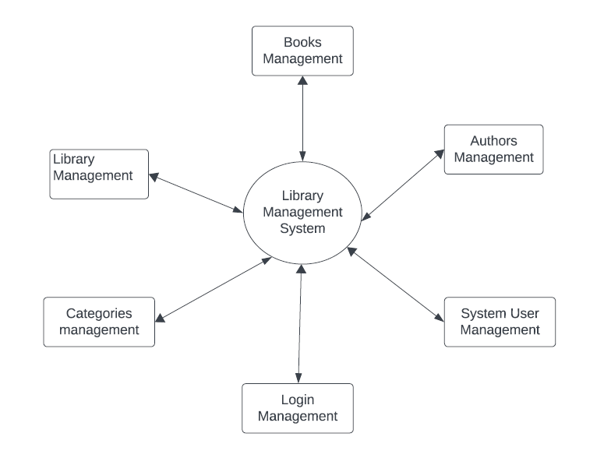

**Level 0 DFD diagram**

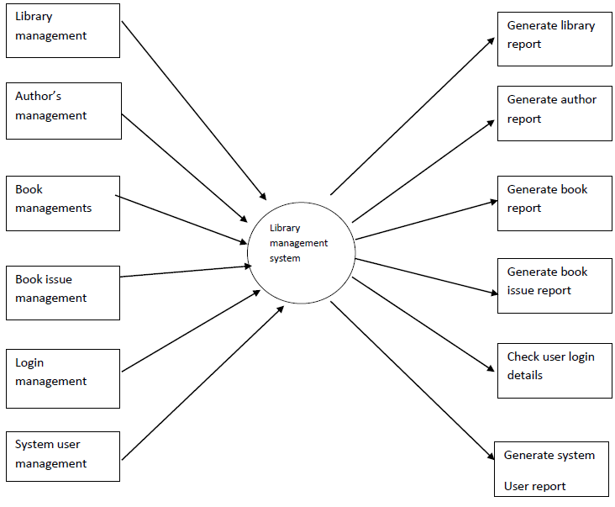

**Level 1 DFD diagram**

**Future Scope of Project**

In our future goal is to make the entire process online where a student can search books, staff can generate reports and do book transactions. It also has a facility for student login where the student can log in and can see the status of books issued as well as request for a book or give some suggestions. It has a facility of teacher's login where teachers can add lecture notes and also give necessary suggestions to the library and also add info about workshops or events happening in our college or nearby college in the online notice board.

As the technology emerges, it is possible to upgrade the system and can be adaptable to desired environment.

**CONCLUSION**

This website provides a computerized version of library management system which will benefit the students as well as the staff of the library.

Library Management System our project allows the admin to store all the book details and the user/student/borrowers details. The system is strong enough to withstand the operations under the conditions where the database is maintained and cleared over a certain time of span. The implementation of the system in the organization will reduce the manual efforts, time, and it is also a smart way of storing the library data

In this project, the user is provided with an online system that can be used to issue and return books in library management online. It should be convenient for the student to view the contents of their status .The library System provides a number of features that are designed to make the student more comfortable. This project helps in understanding the creation of an interaction and the transparency between the student and the librarian of the books through the system.

**REFERENCES**

* <http://www.w3schools.com/html/html_intro.asp>
* <https://www.w3schools.com/php/default.asp>
* https://www.w3schools.com/sql/default.asp
* Fundamentals of software engineering by Rajib mall, PHIlearning
* Web development and application development by Ivan Byross BPB publications